haaptsuukst̓aʔł
hahp/t/sook/s/tah/lth
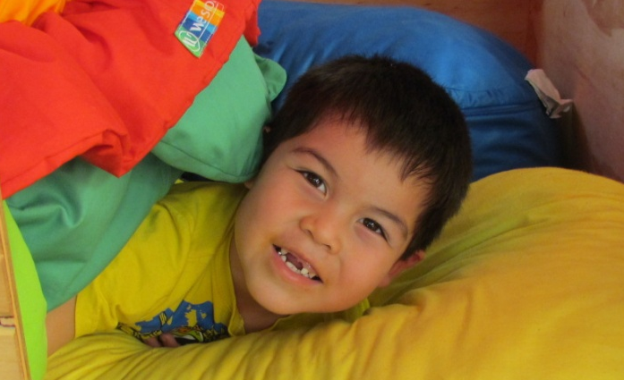
Hide-and-seek
Kyuquot-Checleseht version

Hide-and-seek: Kyuquot-Checleseht version
(CC BY-NC-SA) 2013, Kyuquot-Checleseht and Ehattesaht-Chinehkint language teams

This book was created by the Kyuquot-Checleseht and Ehattesaht-Chinehkint language teams. Its production was supported in part by Ḵa:’yu:’k’t’h’-Che:ḵ’tles7et’h’ First Nations, Ehattesaht-Chinehkint Tribe, and a grant under the Nuu-chah-nulth Language and Culture Program, administered by the Nuu-chah-nulth Economic Development Corporation and the Primate’s World Relief and Development Fund. We gratefully acknowledge our sponsors, our supporters, and our language teams.

This work is distributed under a Creative Commons Attribution Non-Commercial Share-Alike licence (CC BY-NC-SA). It may be freely altered, translated, reproduced, and distributed. It may not be used for commercial purposes. Derivative works must acknowledge “Kyuquot-Checleseht and Ehattesaht-Chinehkint language teams”.

taakšiʔč qum̓aa n̓aas n̓amałšƛ ciiqciqsas.
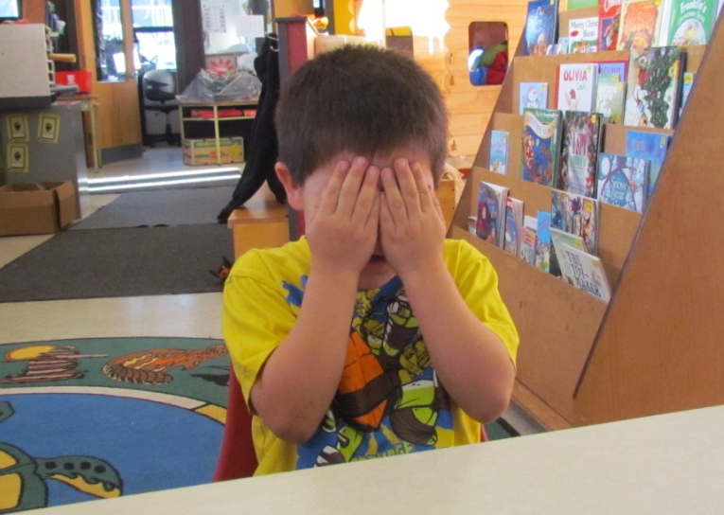
haaptsuukst̓aʔłʕaan!
hahp/t/sook/s/tah/lth/ahn

haptšiʔč | t̓aatn̓aʔs!
hup/t/shee/ch | taht/nah/s

huksčiƛaqƛs | ʔucičƛ | ḥayu.
hook/s/chi/tluk/tl/s | oo/tsich/tl | hah/yoo

Let’s play hide-and-seek! Hide, children! I will count to ten.

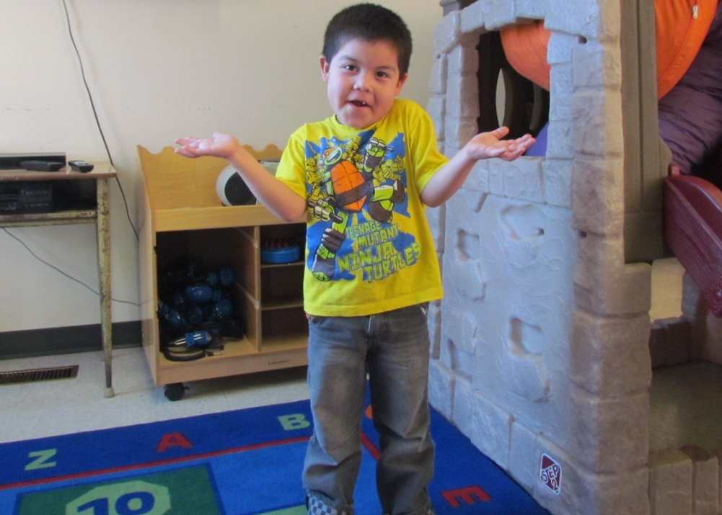
waasaḥ | ___.
wah/suh

ʔins | hayimḥ | hiłii.
in/s | hah/yim/h | hi/thlee

Where is ___? I do not know where she is.

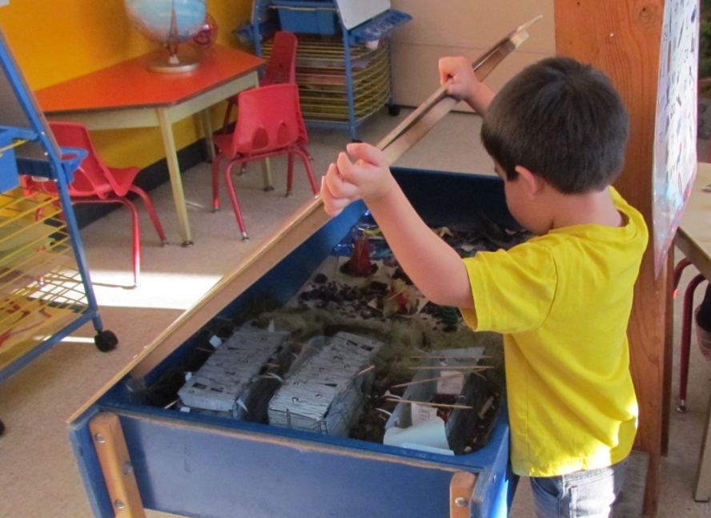
wikʔiiš | hiiłsit | č̓aacnaʕły̓iki.
wik/eesh | heelth/sit | chahts/nah/lth/yi/ki
She is not in the water table.

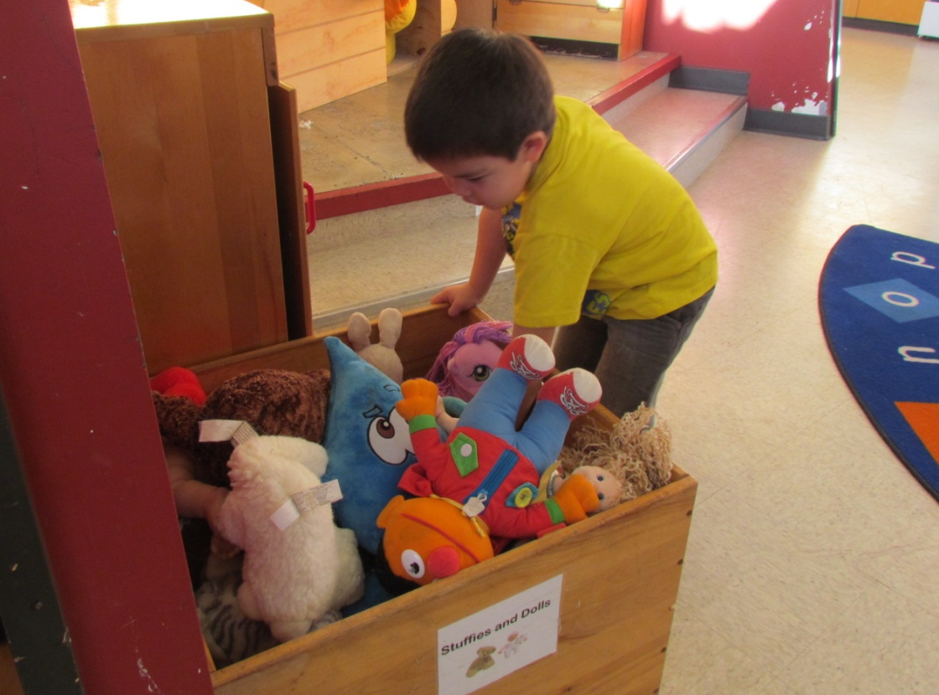
wikʔiiš | hiłc̓uu | ƛ̓aḥaqsi.
wik/eesh | hilth/tsoo | tluh/huk/si
She is not in the box.

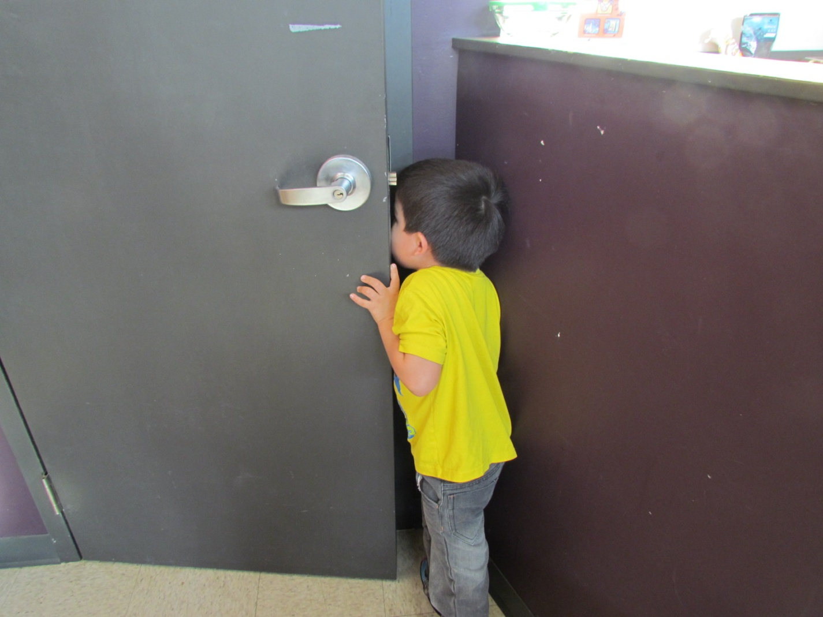
wikʔiiš | hiy̓aqƛ | p̓atqc̓uuč̓ki.
wik/eesh | hi/yuk/tl | put/k/tsooch/ki
She is not in the closet.

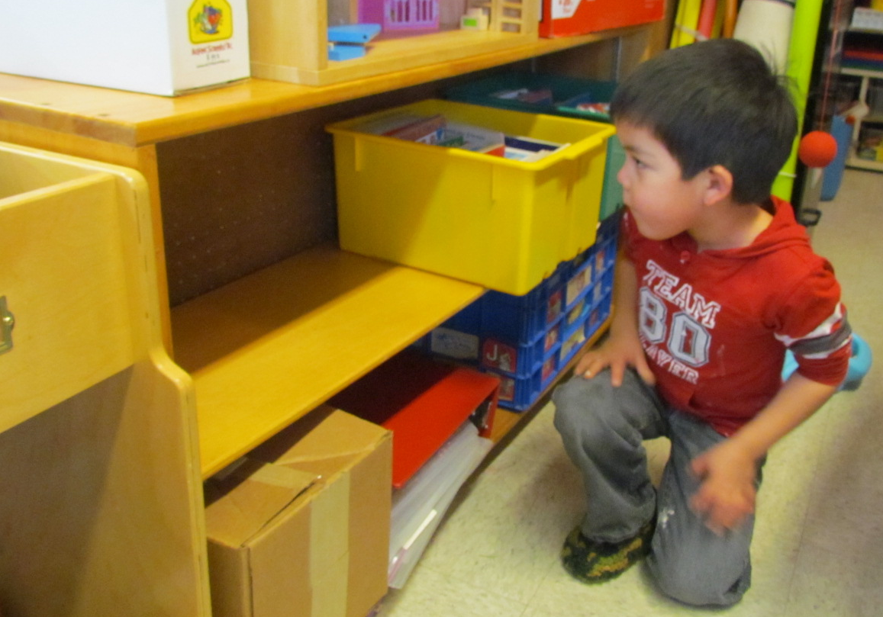
wikʔiiš | hiłaas | puuksac̓im.
wik/eesh | hi/thlahs | pook/sah/tsim
She is not on the shelf.

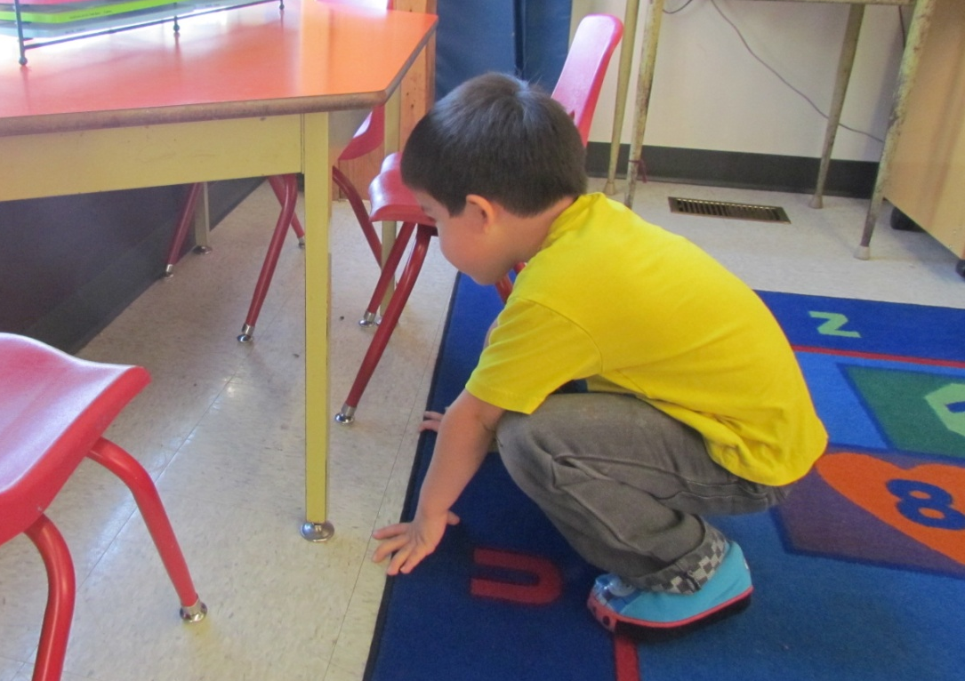
wikʔiiš | hiiłcapuʔł | tiipin.
wik/eesh | heelth/tsuh/poo/lth | tee/pin
She is not under the table.

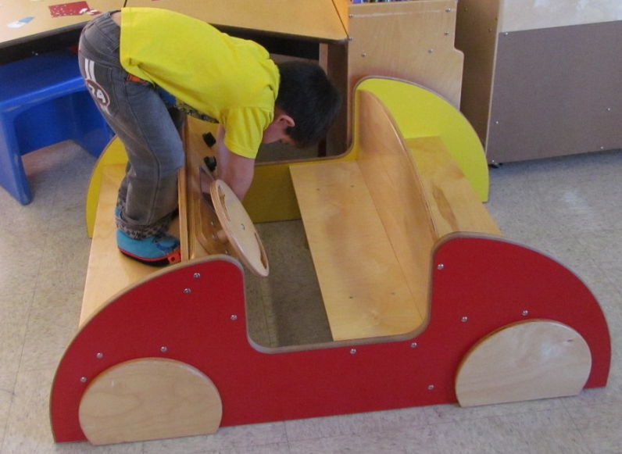
wikʔiiš | hiy̓aḥs | c̓ikc̓iki.
wik/eesh | hi/yuh/s | tsik/tsi/ki
She is not in the car.

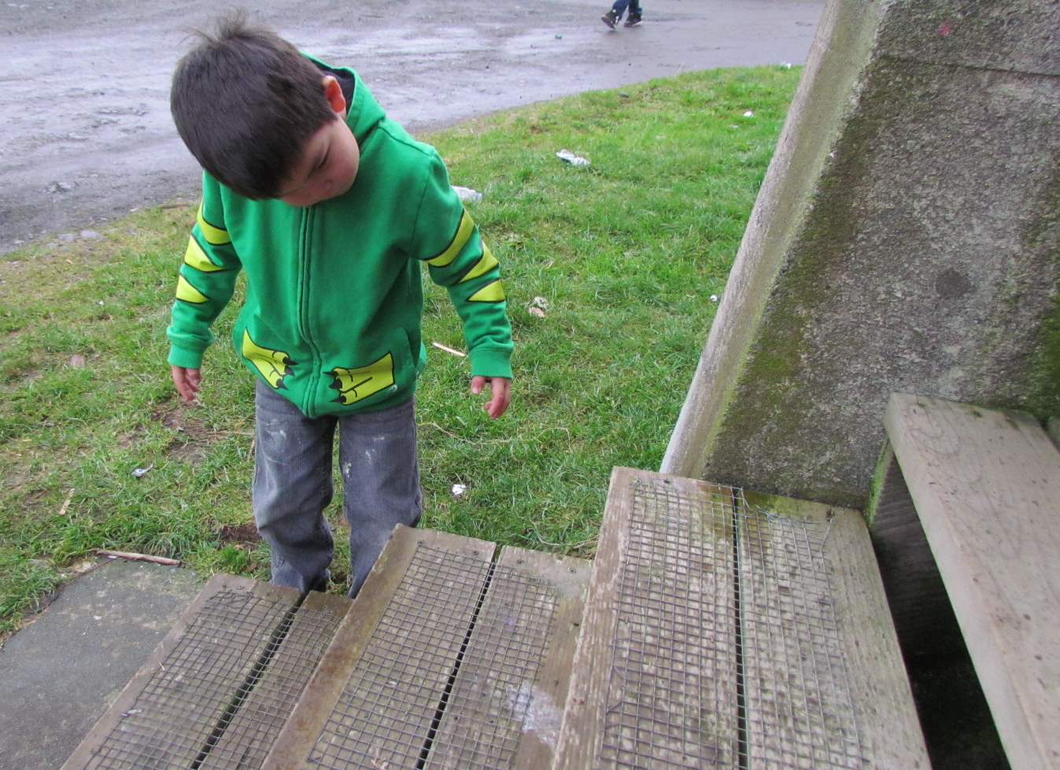
wikʔiiš | hiiłcapoʕs | xaʔupʕasi.
wik/eesh | heelth/tsuh/poh/s | khuh/oop/uh/si
She is not under the stairs.

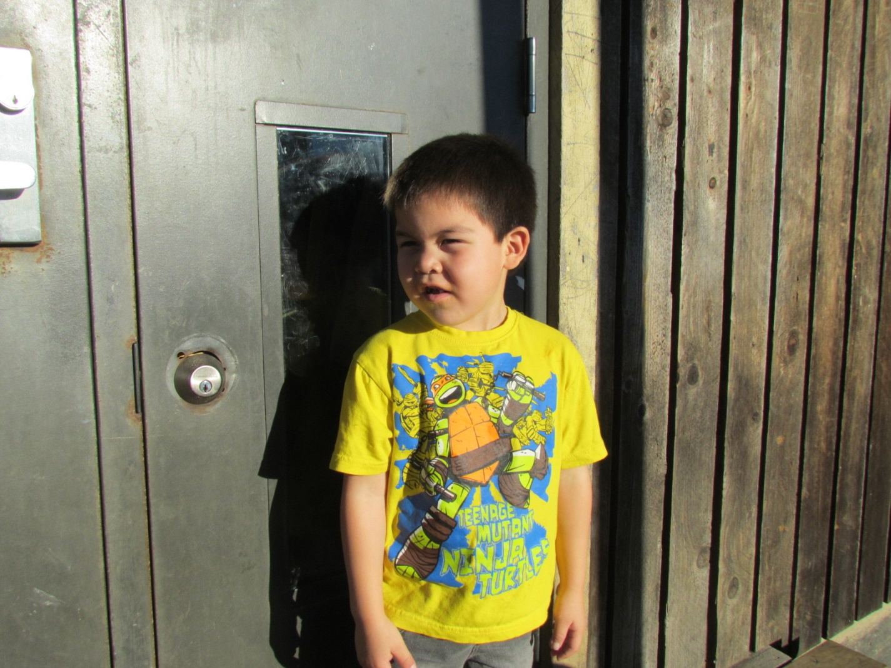
wik̓iitiš | ƛ̓aaʔaas.
wi/kee/tish | tlah/ahs
There’s no sign of her outdoors.

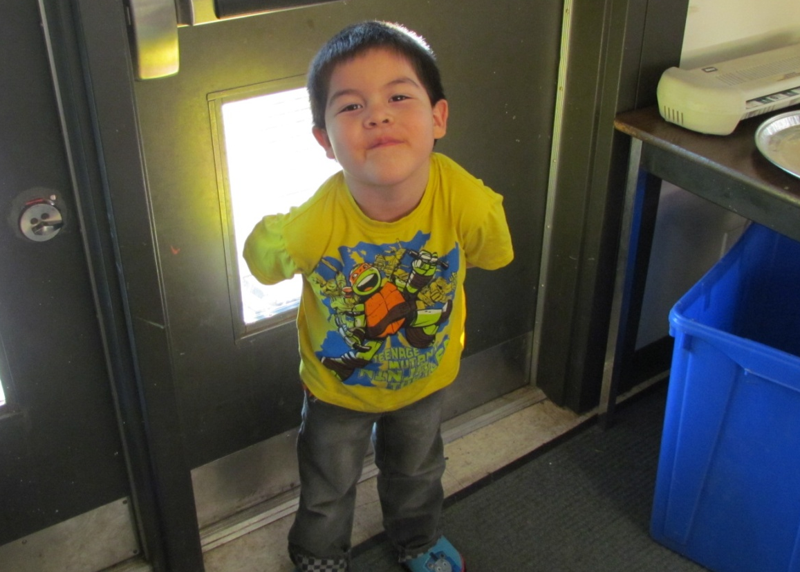
wik̓iitiš | mačiił.
wi/kee/tish | muh/cheelth
There’s no sign of her indoors.

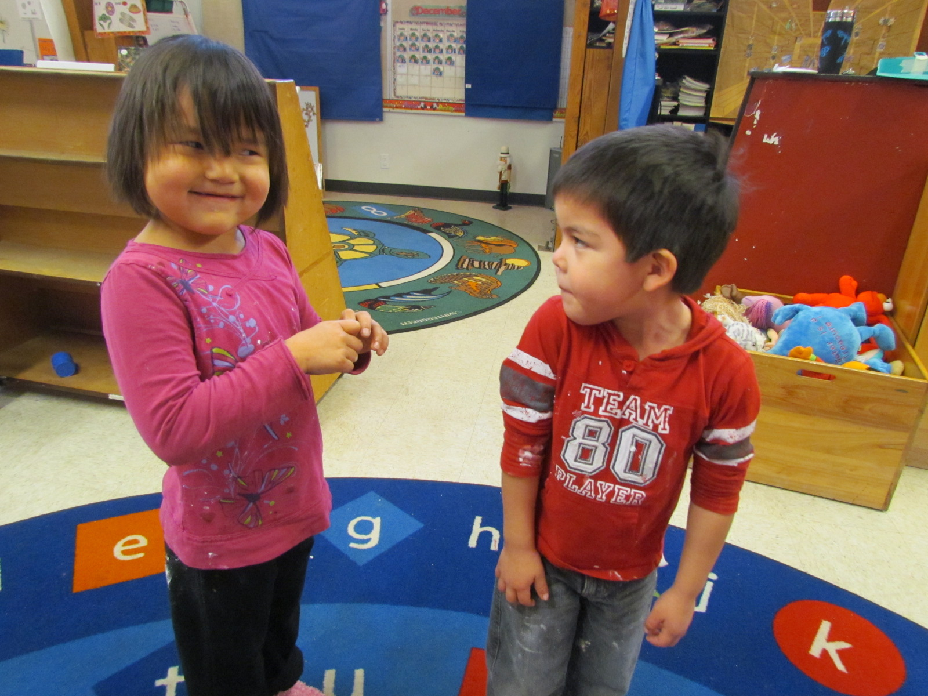
ʔi! | hiinaʔƛiis!
i | hee/nah/tlees

hiłkumqƛaʔš | siičił!
hilth/koom/k/tlah/sh | see/chilth

Ah! I found her! She’s behind me!

The Nuu-chah-nulth alphabet
quick pronunciation guide

a | uh | o | oh or aw
aa | long ah | oo | long oh or aw
c | ts | p | p
c̓ | explosive ts | p̓ | explosive p
č | ch | q | back k
č̓ | explosive ch | qʷ | rounded back k
ee | long eh | s | s
h | h | š | sh
ḥ | raspy h | t | t
i | as in bit | t̓ | explosive t
ii | as in ski, and long | u | as in put
k | k | uu | as in due, and long
kʷ | rounded k | w | w
k̓ | explosive k | w̓ | w with a catch
k̓ʷ | rounded explosive k | x | hissed k
ł | hissed l | xʷ | rounded hissed k
ƛ | tl | x̣ | hissed q
ƛ̓ | explosive tl | x̣ʷ | rounded hissed q
m | m | y | y
m̓ | m with a catch | y̓ | y with a catch
n | n | ʔ | catch in throat
n̓ | n with a catch | ʕ | catch in throat plus r

