ʔanaḥʔisʔi ƛiisuwił
uh/nuh/is/i tlee/soo/wilth

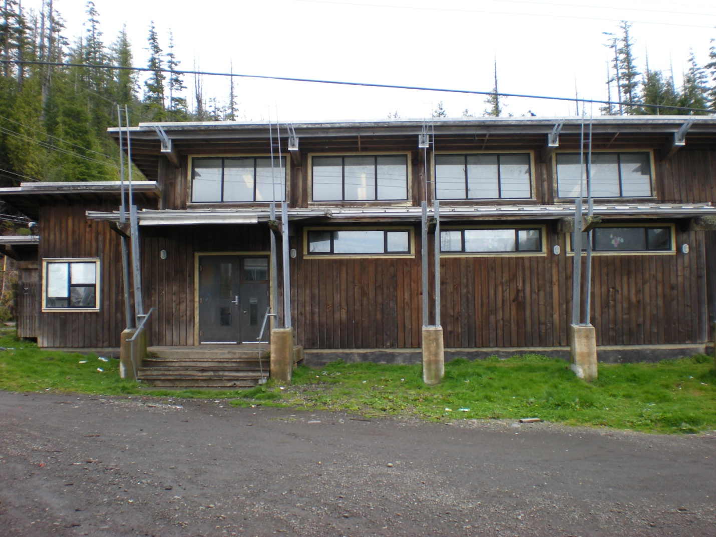
The Little School
Northern Nuu-chah-nulth version

The Little School: Northern Nuu-chah-nulth version
(CC BY-NC-SA) 2013, Kyuquot-Checleseht and Ehattesaht-Chinehkint language teams

This book was created by the Kyuquot-Checleseht and Ehattesaht-Chinehkint language teams. Its production was supported in part by Ḵa:’yu:’k’t’h’-Che:ḵ’tles7et’h’ First Nations, Ehattesaht-Chinehkint Tribe, and a grant under the Nuu-chah-nulth Language and Culture Program, administered by the Nuu-chah-nulth Economic Development Corporation and the Primate’s World Relief and Development Fund. We gratefully acknowledge our sponsors, our supporters, and our language teams.

This work is distributed under a Creative Commons Attribution Non-Commercial Share-Alike licence (CC BY-NC-SA). It may be freely altered, translated, reproduced, and distributed. It may not be used for commercial purposes. Derivative works must acknowledge “Kyuquot-Checleseht and Ehattesaht-Chinehkint language teams”.

ʔutwiiʔiłʔap̓i ciciqiʔakʔik.
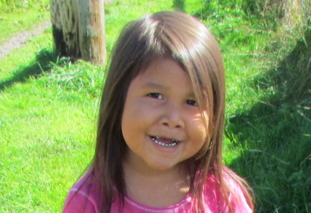
ʔukłaas | ___.
ook/thlahs
My name is ___.
hiłḥsʔaał | ƛiisƛiisa | ʔanaḥʔisʔi
hilth/h/s/ahlth | tlees/tlee/suh | uh/nuh/is/i

ƛiisuwił.
tlee/soo/wilth

I learn at the little school.

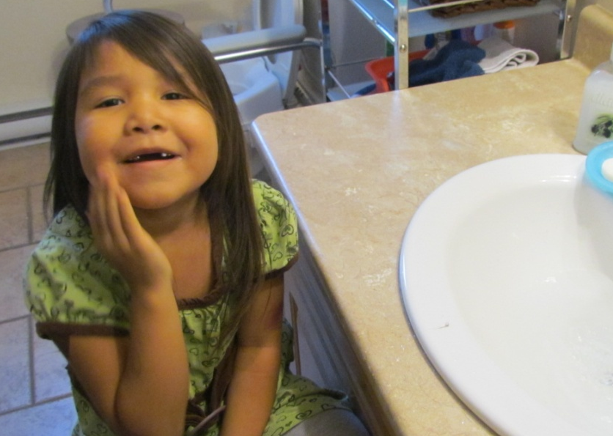
kuʔałʔaƛqu, | wikyuuqus
koo/ulth/utl/koo | wik/yoo/koos

ƛiisƛiisaw̓it̓as, | ƛ̓ipšiƛsʔał.
tlees/tlee/suh/wi/tus | tlip/shitl/s/ulth

In the morning, before I go to school, I wash my face.

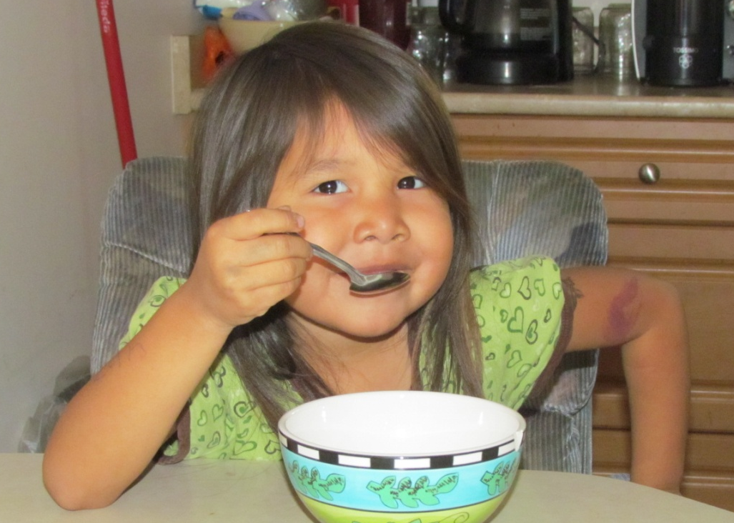
ƛułsʔaał | haʔuk.
tloolth/s/ahlth | huh/ook
I eat a good breakfast.

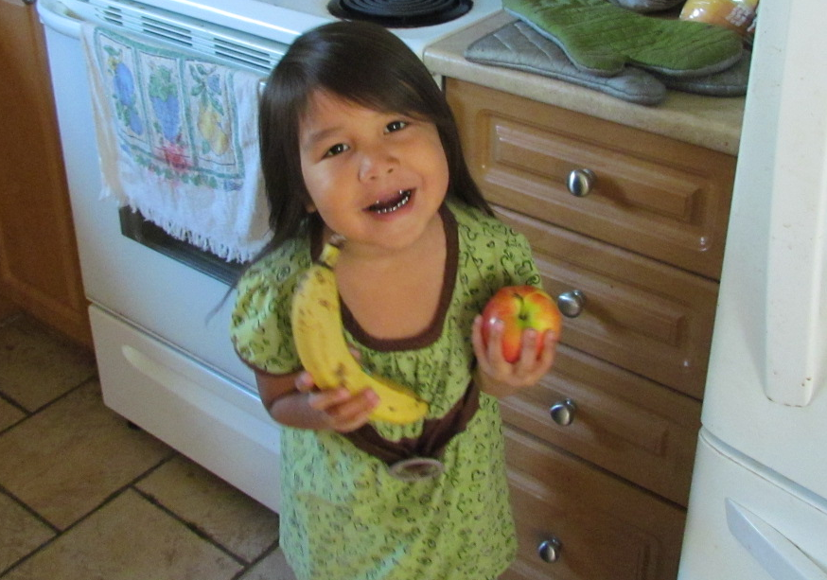
hawičaqsapsʔał | kuukukqs
huh/wi/chuk/sup/s/ulth | koo/kook/k/s

hiniicw̓it̓as.
hi/neets/wi/tus

I get my snacks ready to take to school.

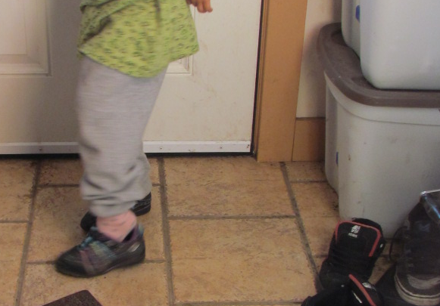
ʔuuqumḥiʔaƛqu,
oo/koom/heh/utl/koo

šuušuuwisḥtinƛsʔał.
shoo/shoo/wis/h/tin/tl/s/ulth

If it’s nice out, I put on my shoes.

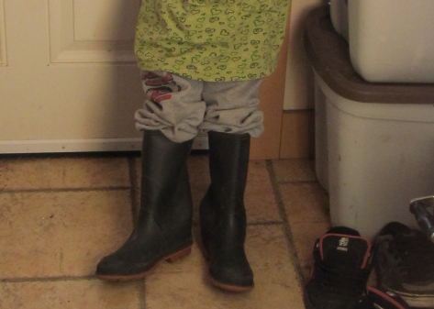
wiiqsiiʔaƛqu,
week/see/utl/koo

kaakampucḥtinƛsʔał.
kah/kum/poots/h/tin/tl/s/ulth

If it’s stormy, I put on my gumboots.

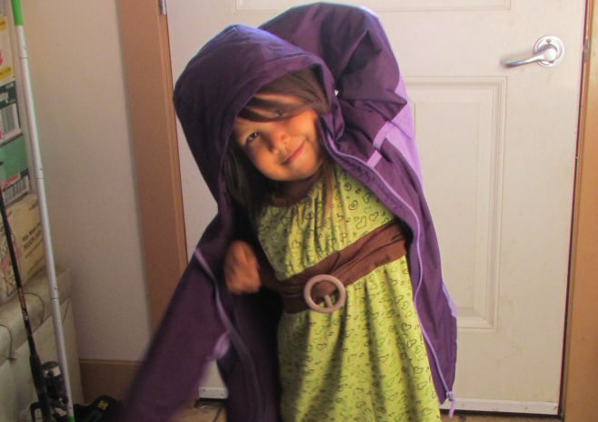
kuutʔičuƛsʔał.
koot/i/chootl/s/ulth
I put on my coat.

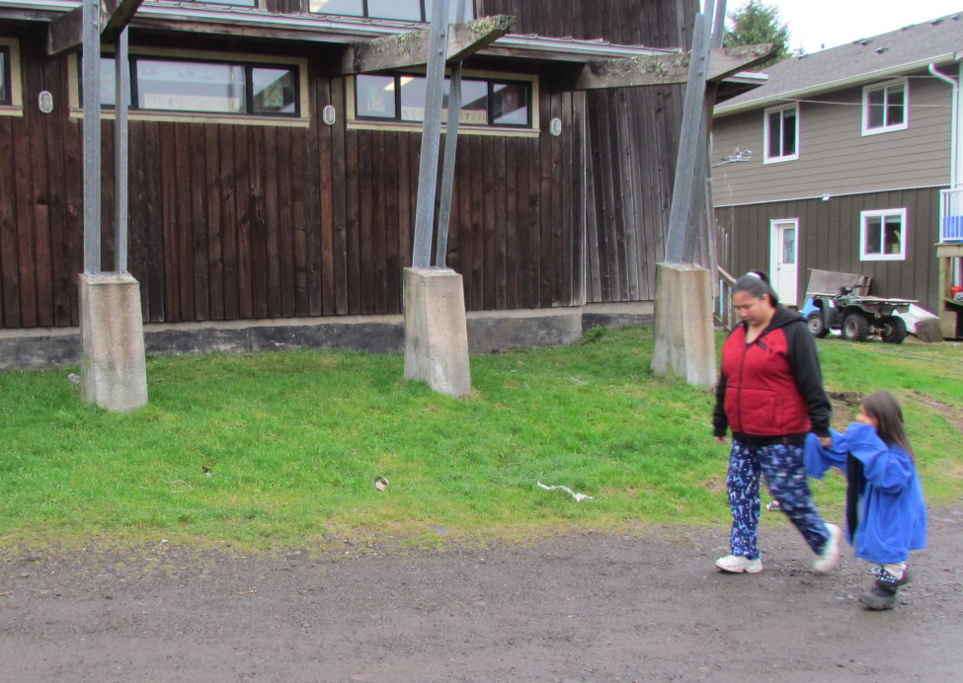
ʔumʔiiqsakqs | ʔukʷinksʔał
oom/eek/suk/k/s | oo/kwin/k/s/ulth

ʔucačiƛ | ƛiisuwił.
oo/tsuh/chitl | tlee/soo/wilth

I walk to school with my mom.

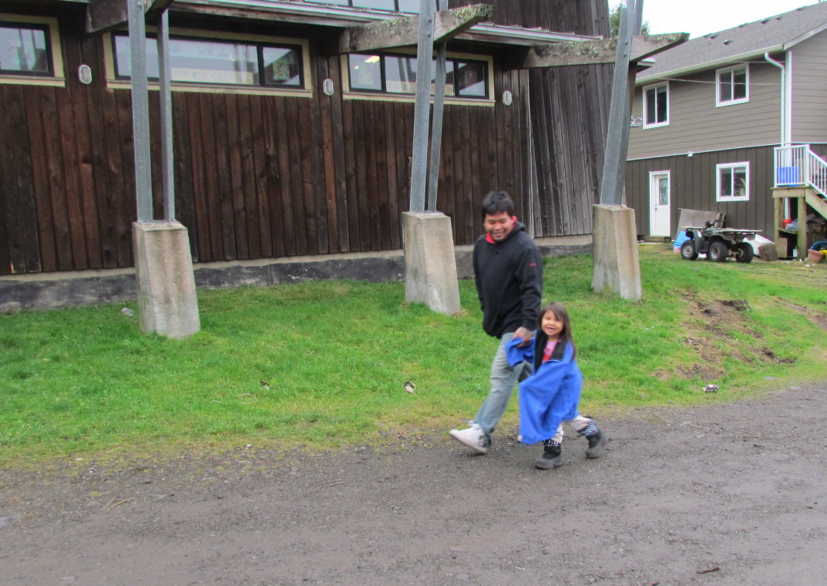
ʔuušyuuyatsʔał | maw̓aaʔat
oosh/yoo/yut/s/ulth | mah/wah/ut

n̓uw̓iiqsakqs | ʔuyiiq | huupuk̓ʷas.
noo/week/suk/k/s | oo/yeek | hoo/poo/kwus

Sometimes my dad brings me by car.

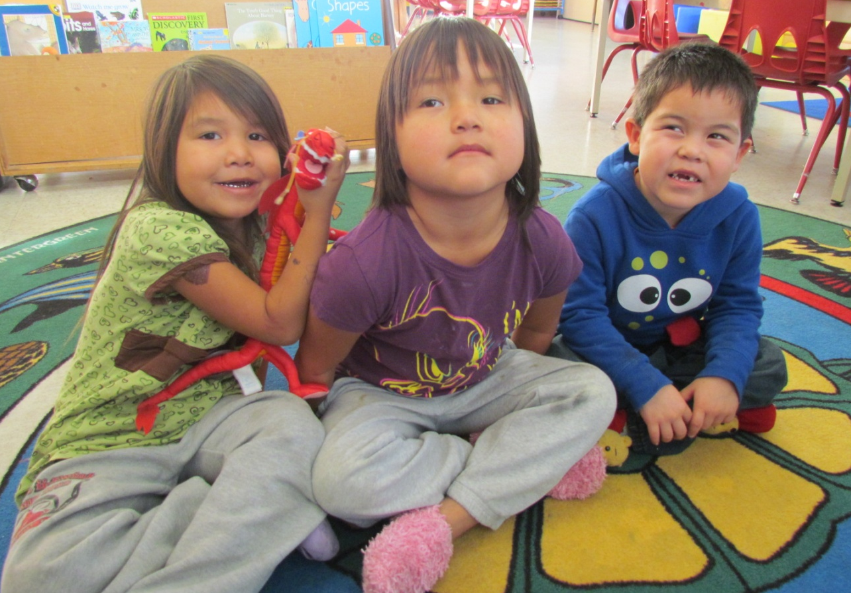
hišumyipiʔaƛqun, | yaqin
hi/shoom/yi/pi/utl/koon | yuh/kin

ƛiisƛiisa | t̓iqʷiłnišʔał | hił
tlees/tlee/suh | ti/kwilth/nish/ulth | hilth

łiciłum.
thli/tsi/thloom

Together at school, we sit on the rug.

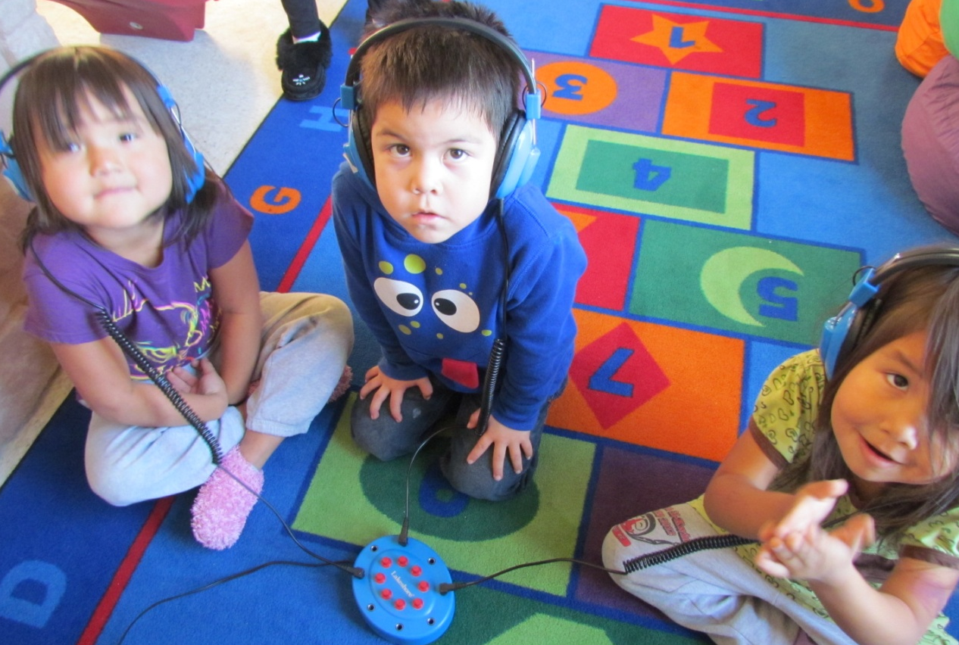
naʔaataḥnišʔał.
nah/ah/tuh/nish/ulth
We listen.

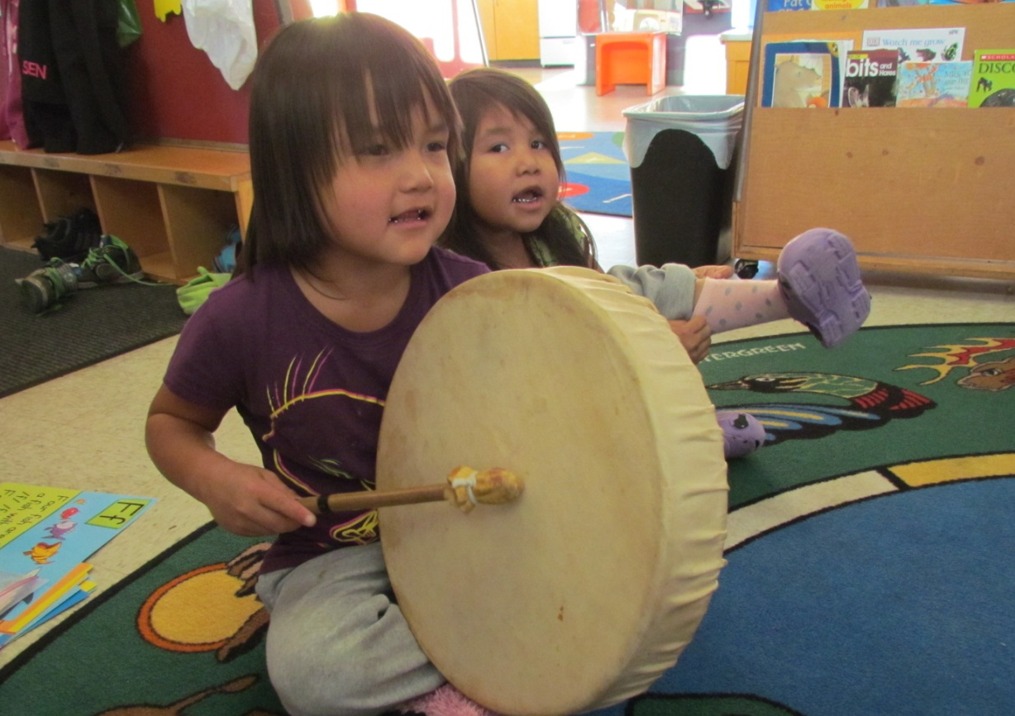
nunuuknišʔał.
noo/nook/nish/ulth
We sing.

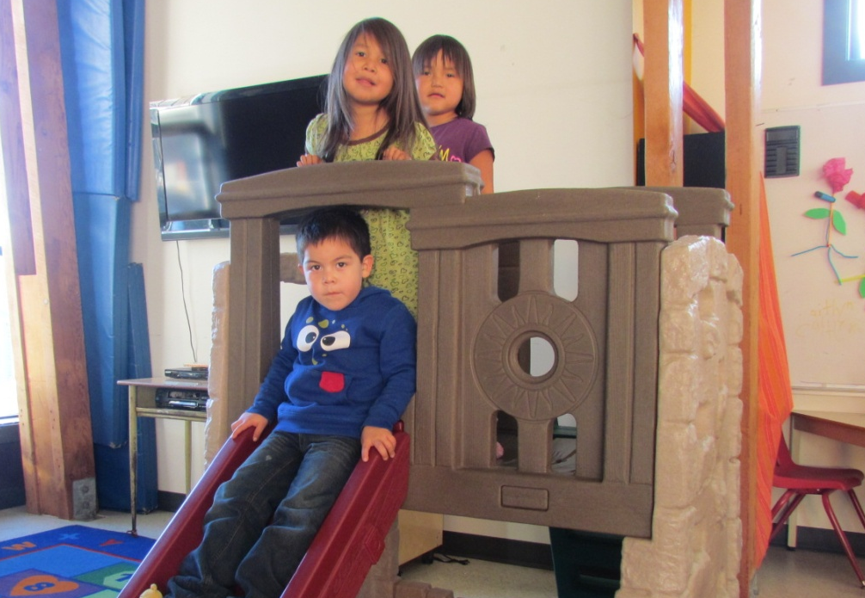
ḥaaʔuukst̓ałnišʔał.
hah/ook/s/tulth/nish/ulth
We take turns.

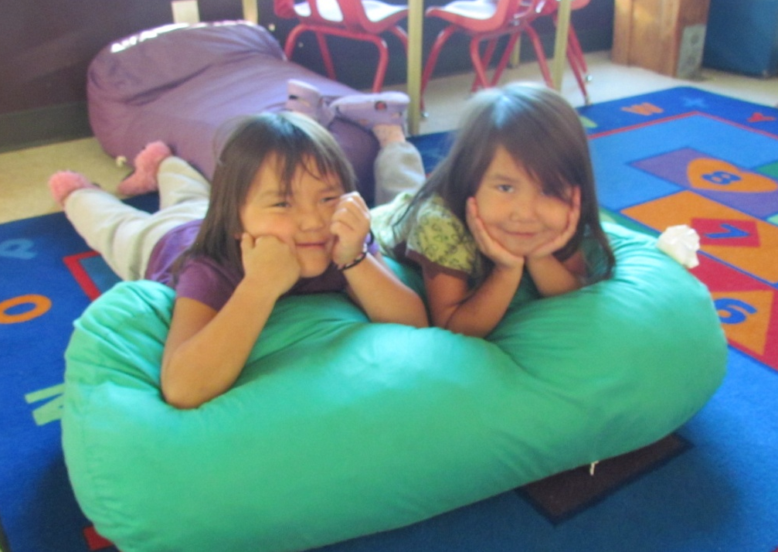
ʔuuḥw̓ałst̓ałʔapnišʔał.
ooh/wulth/s/tulth/up/nish/ulth
We share.
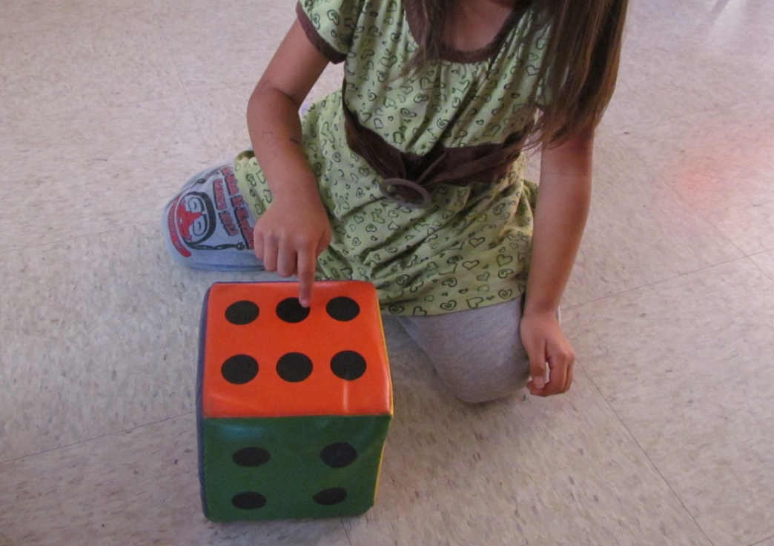
huksaanišʔał.
hook/sah/nish/ulth
We count.

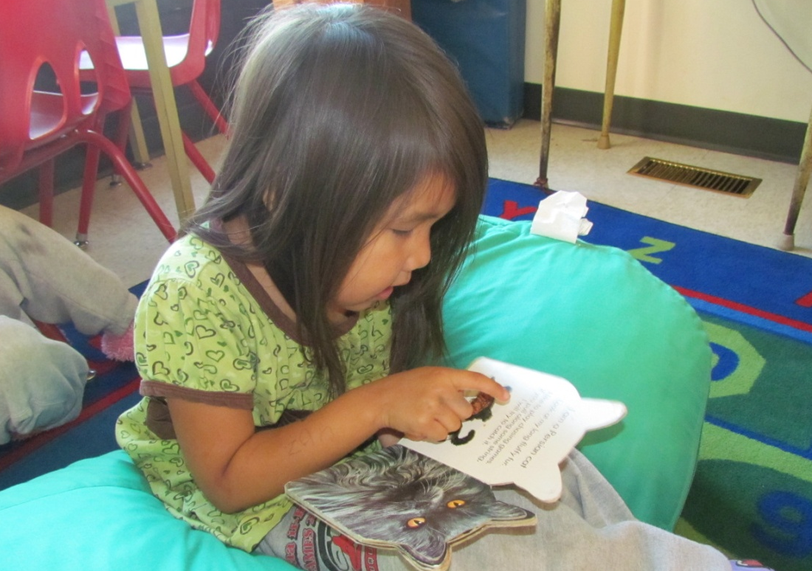
n̓ačaałnišʔał.
nuh/chahlth/nish/ulth
We read.

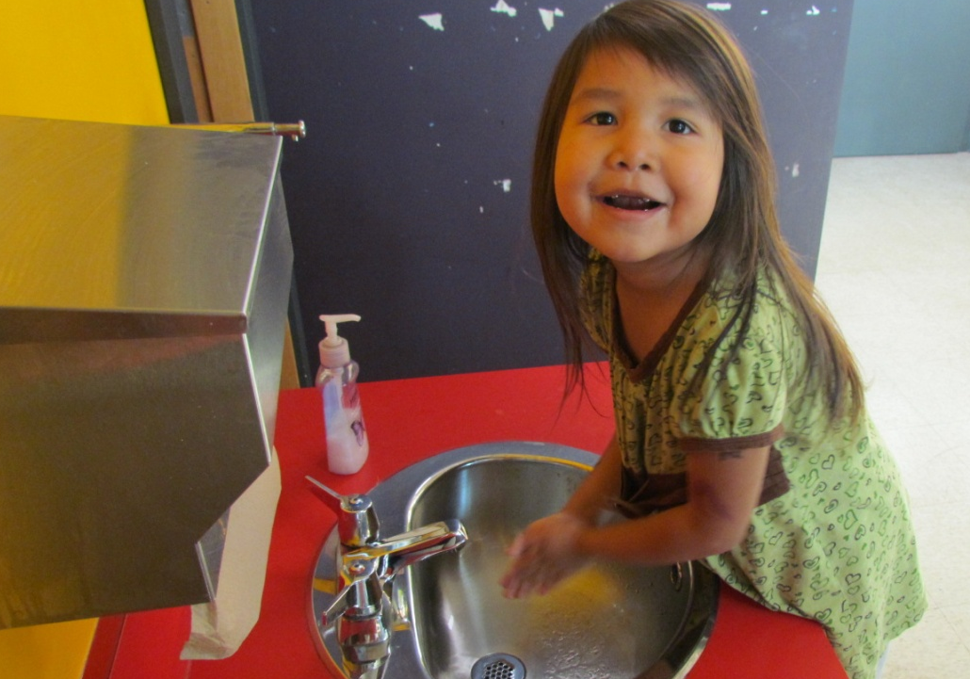
c̓uc̓inknišʔał.
tsoo/tsin/k/nish/ulth
We wash our hands.

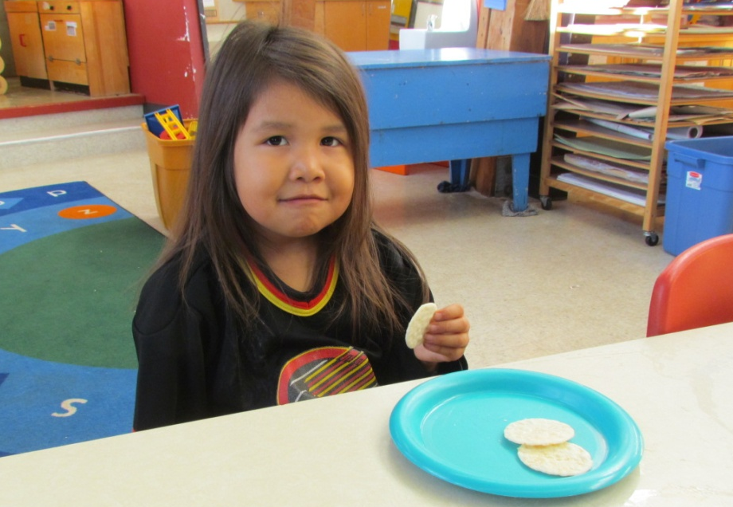
haʔuknišʔał.
huh/ook/nish/ulth
We eat.

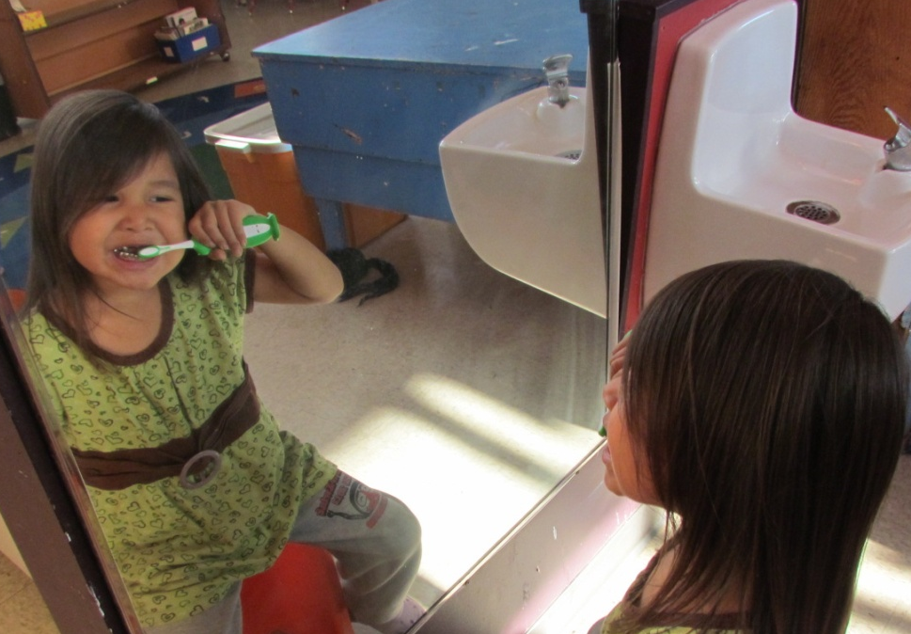
c̓uc̓umy̓aqƛ̓aḥsnišʔał.
tsoo/tsoom/yuk/tluh/s/nish/ulth
We brush our teeth.

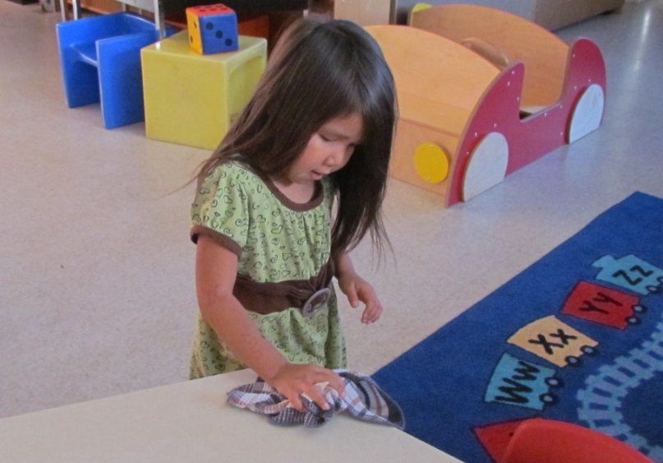
timałasnišʔał | ƛiissac̓um.
ti/muh/thlus/nish/ulth | tlees/sah/tsum
We wipe tables.

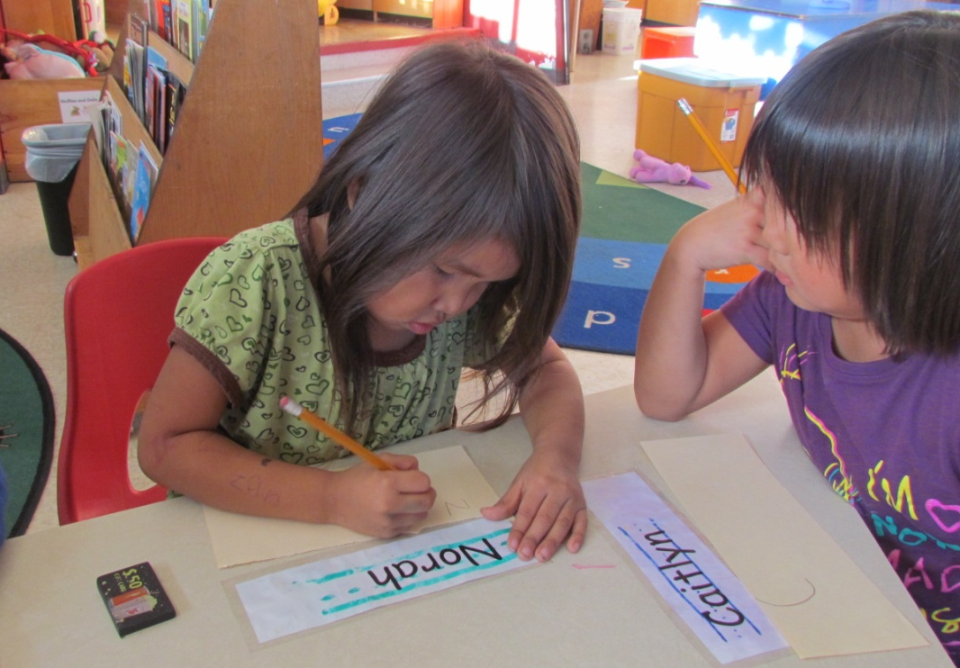
ƛiisƛiisanišʔał.
tlees/tlee/suh/nish/ulth
We print.

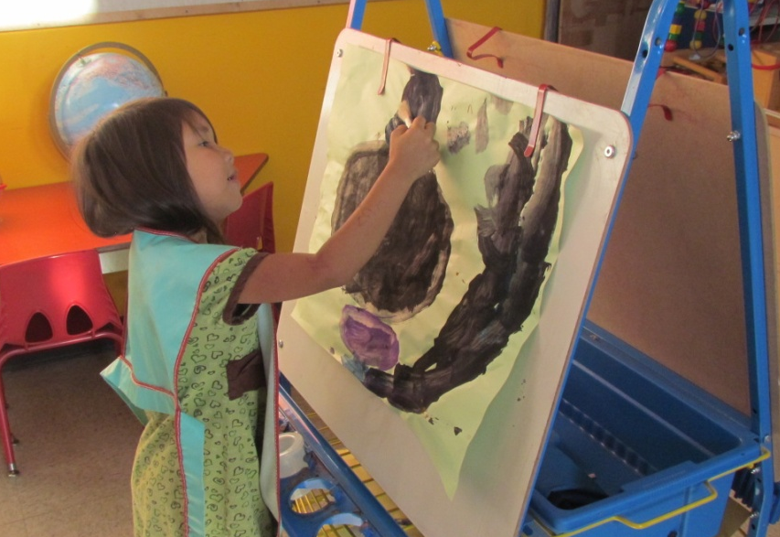
piintpiintanišʔał.
peen/t/peen/tuh/nish/ulth
We paint.

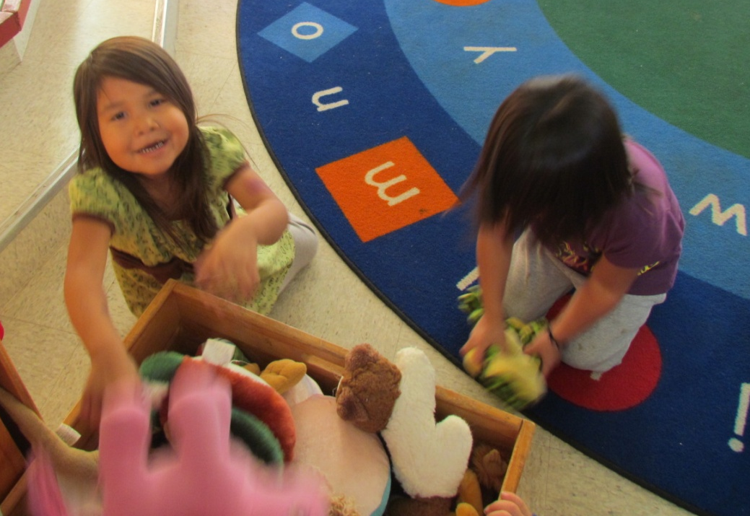
k̓ašsaapnišʔał.
kush/sahp/nish/ulth
We put things away.

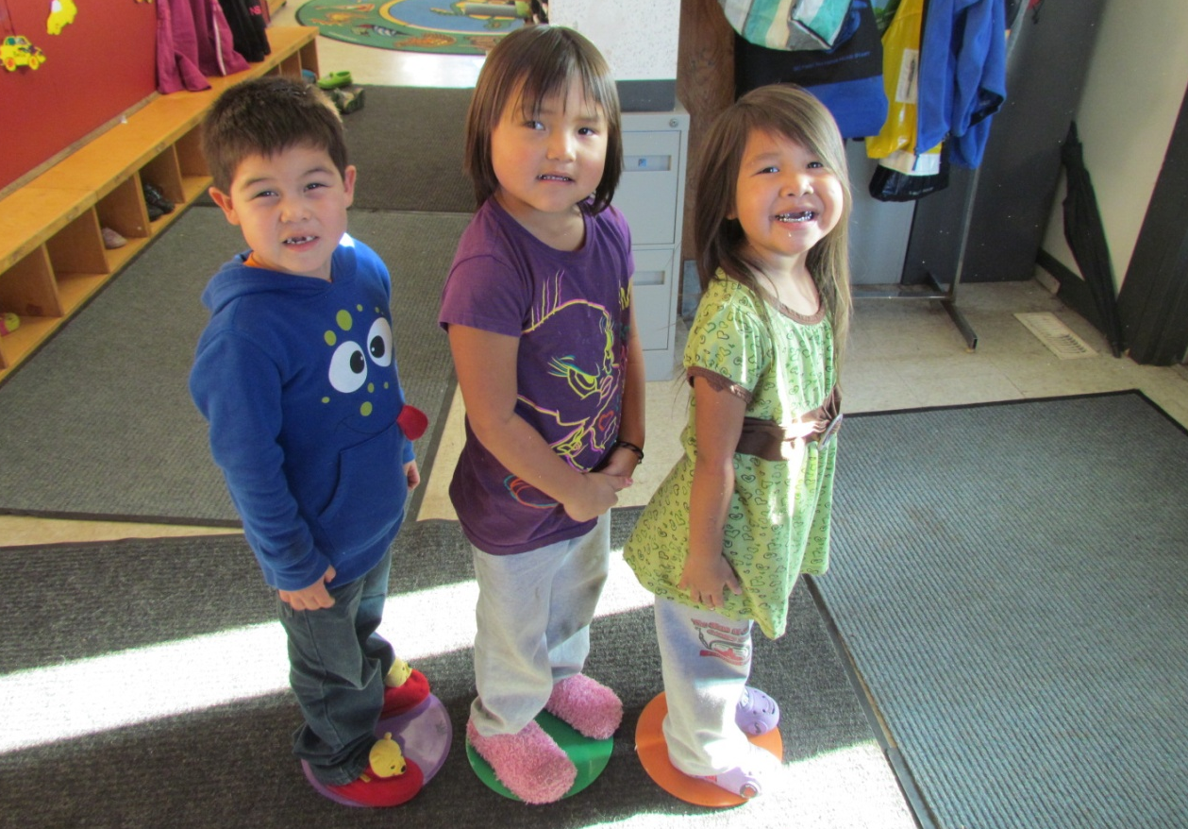
c̓ispiƛnišʔał.
tsis/pitl/nish/ulth
We line up.

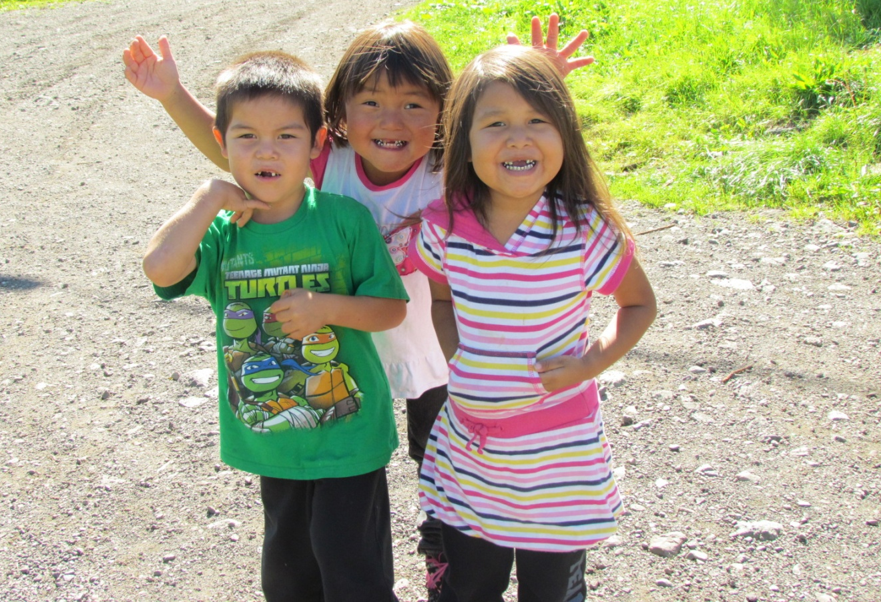
kaapaps | ƛaƛuuʔi | t̓aatn̓a.
kah/pup/s | tluh/tloo/i | taht/nuh
I like the other children.

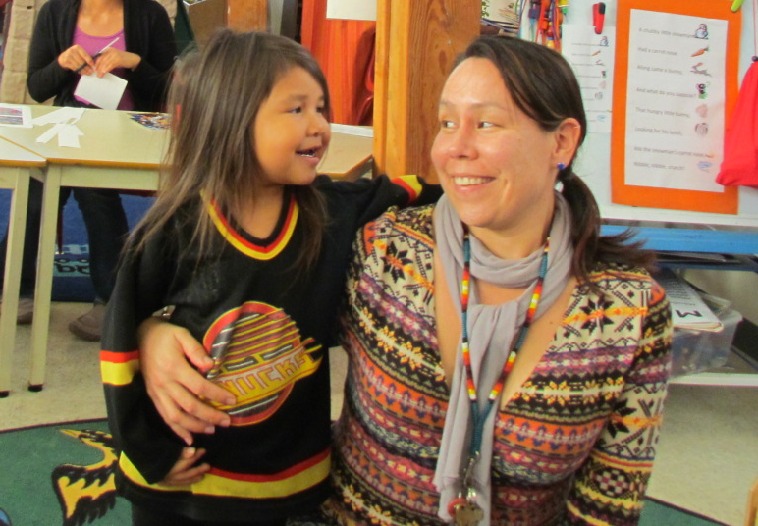
kaapaps | huuḥtikšiiḥʔapʔi | siičił.
kah/pup/s | hooh/tik/sheeh/up/i | see/chilth
I like my teacher.

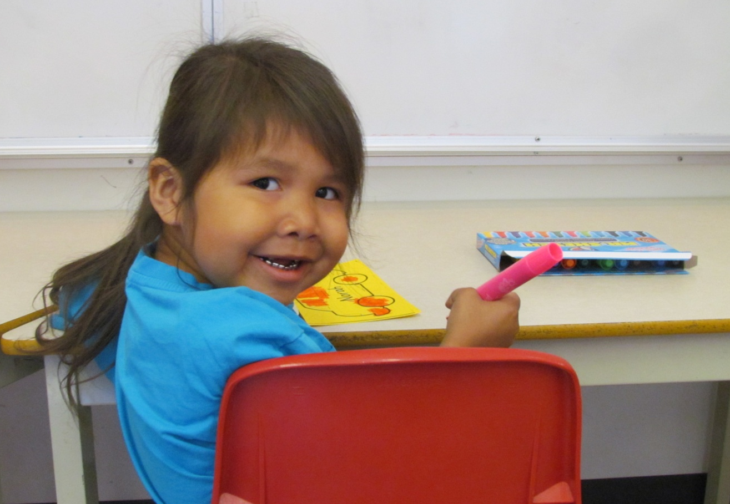
ʔuuqmisḥʔats | ƛiisƛiisaʕas.
ook/mis/h/ut/s | tlees/tlee/suh/us
I like going to school.

The Nuu-chah-nulth alphabet
quick pronunciation guide

a | uh | o | oh or aw
aa | long ah | oo | long oh or aw
c | ts | p | p
c̓ | explosive ts | p̓ | explosive p
č | ch | q | back k
č̓ | explosive ch | qʷ | rounded back k
ee | long eh | s | s
h | h | š | sh
ḥ | raspy h | t | t
i | as in bit | t̓ | explosive t
ii | as in ski, and long | u | as in put
k | k | uu | as in due, and long
kʷ | rounded k | w | w
k̓ | explosive k | w̓ | w with a catch
k̓ʷ | rounded explosive k | x | hissed k
ł | hissed l | xʷ | rounded hissed k
ƛ | tl | x̣ | hissed q
ƛ̓ | explosive tl | x̣ʷ | rounded hissed q
m | m | y | y
m̓ | m with a catch | y̓ | y with a catch
n | n | ʔ | catch in throat
n̓ | n with a catch | ʕ | catch in throat plus r

